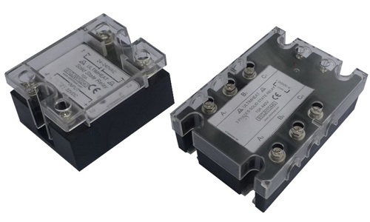
Type 91GJW and 91GJH
Single and three-phase solid state relays
Solid state relay, 3-32VDC input, cut to zero. Compatible with the relay (SSR) output of electronic controllers.
Input signal: 3-32V DC, 3 to 35 mA current (single phase), 12 to 25 mA current (3 phases).
Voltage drop in open position (current lowing): <1.5VAC.
Dielectric insulation: 2500 VAC.
Insulation resistance: > 100 Mohms /500VAC.
Operating temperature: -30 + 75℃.

